# **SCD Type 1**

Slowly Changing Dimension Type 1 do not preserve any history versions of data. This methodology overwrites old data with new data, and therefore stores only the most current information.

Step by step implementation of SCD Type 1 using Informatica Power Center.

Below is the structure of source table.

[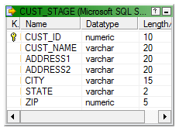](http://lh4.ggpht.com/-LAnDuT9SVMQ/UOpRtv7by3I/AAAAAAAAGo4/HMC6MonnA5k/s1600-h/image%25255B8%25255D.png)

Source table will have only current data. Data is uniquely identified using CUST_ID.

Below is the structure of Dimension table or target .

[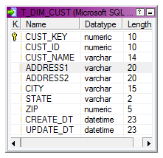](http://lh3.ggpht.com/-u4erQ3FM-js/UQn2G2m6wYI/AAAAAAAAHEs/vI7ObvmSFVk/s1600-h/image%25255B7%25255D.png)  
CUST_KEY is the surrogate key.

CUST_ID is the Natural key, the unique record identifier.

SCD Type 1 Mapping:

**Step 1**  
Drag the CUST_STAGE source definition into the mapping designer.

[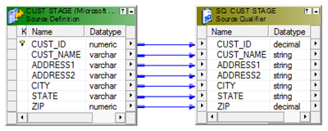](http://lh5.ggpht.com/-H0ueQlnoZyc/UOpRv8TLmWI/AAAAAAAAGpY/S_lGbs7Pk6E/s1600-h/image%25255B14%25255D.png)

**Step 2**  
Next using a LookUp Transformation fetch the existing Customer columns from the dimension table T_DIM_CUST. This lookup will give NULL value if the customer does not exist.

LookUp Condition : IN_CUST_ID = CUST_ID

Return Columns : CUST_KEY

[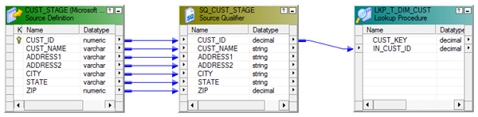](http://lh5.ggpht.com/-Ix8P1sldUG4/UQn2H5iIofI/AAAAAAAAHE8/ujwNjfmFzbs/s1600-h/image%25255B12%25255D.png)

**Step 3**  
Use an Expression Transformation to identify the records for Insert and Update. Below expression identifies the record.

INS_UPD :- IIF(ISNULL(CUST_KEY),'INS', 'UPD')

Create two output ports.  
CREATE_DT :- SYSDATE

UPDATE_DT :- SYSDATE

[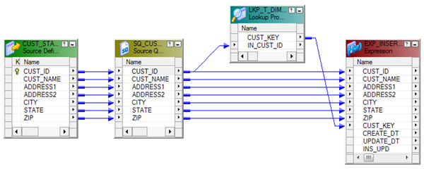](http://lh5.ggpht.com/-peXvewOtPp4/UQn2Ihz1hBI/AAAAAAAAHFM/0Ad17GZxBzI/s1600-h/image%25255B16%25255D.png)

**Step 4**  
Map the columns from the Expression Transformation to a Router Transformation and create two groups (INSERT, UPDATE) in Router Transformation using the below expression.   
INSERT :- IIF(INS_UPD='INS',TRUE,FALSE)

UPDATE :- IIF(INS_UPD='UPD',TRUE,FALSE)

[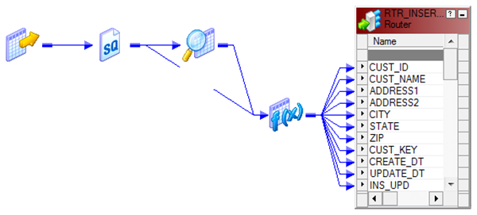](http://lh3.ggpht.com/-3fN3sWiUoD4/UQn2J9jqtMI/AAAAAAAAHFc/KMoTlKn8tnk/s1600-h/image%25255B20%25255D.png)

Insert Group:

**Step 5**  
Every records coming through the 'INSERT Group' will be inserted into the Dimension table T_DIM_CUST.  
  
Use a Sequence generator transformation to generate surrogate key CUST_KEY. And map the columns from the Router Transformation to the target.

[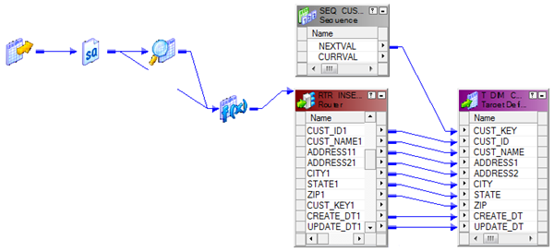](http://lh6.ggpht.com/-bJoiia_dqE0/UQn2LXEr3BI/AAAAAAAAHFs/fh-qlcfmICk/s1600-h/image%25255B24%25255D.png)  
(Update Strategy transformation is not used for the records that are set for Insert.)

**Step 6**  
Records coming from the 'UPDATE Group' will update the customer Dimension with the latest customer attributes. Add an Update strategy transformation before the target instance and set it as DD_UPDATE. Below is the structure of the mapping.

[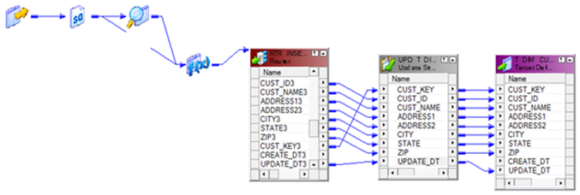](http://lh5.ggpht.com/-xIAzHmV0L3Y/UQn2Mjdl7HI/AAAAAAAAHF8/Xc17chA8QwM/s1600-h/image%25255B28%25255D.png)  
Completed Mapping:  
[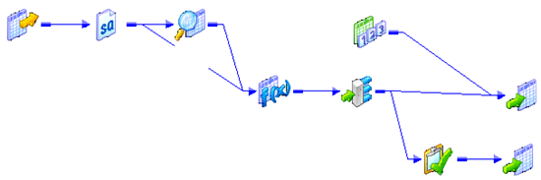](http://lh3.ggpht.com/-6K13mYGZVuE/UQn2S0ECAmI/AAAAAAAAHGM/f1MhB7gtqPE/s1600-h/image%25255B32%25255D.png)